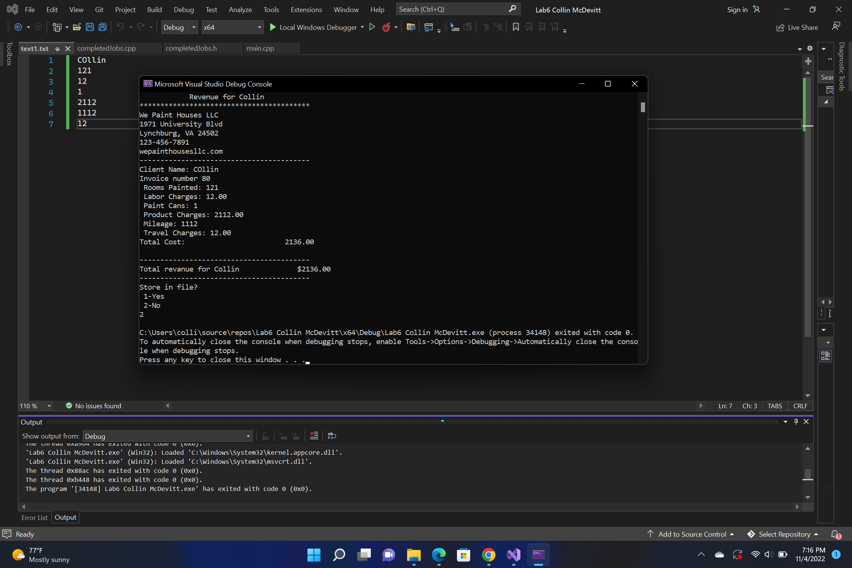

I have not shared the source code in my program with anyone other than my instructor’s approved human sources.

⦁ I have not used source code obtained from another student, or any other unauthorized source, either modified or unmodified.

⦁ If any source code or documentation used in my program was obtained from another source, such as a text book or course notes, that has been clearly noted with a proper citation in the comments of my program.

⦁ I have not knowingly designed this program in such a way as to defeat or interfere with the normal operation of any machine it is graded on or to produce apparently correct results when in fact it does not.

Algorithm

Main

Ask the name of the month

Ask for how many jobs were completed in that month

Use that number to create array of pointer to completed jobs objects

Enter a for loop for the length of the array

dynamically create object in the constructor everything is set to empty or 0 and the rand function is used to give the invoice number for that specific job

Output the menu

ask the user for which option they want

if they enter a 1 then it will call that object and use the method in the object class that will ask for the name of the file and will give the user 4 chances to open the file if the file is unable to be opened after 4 attempts then it will set everything for that object to 0 or empty

if the file that they entered is able to be oppened but there is something wrong with the data that is stored in it it will tell the user that that file doesn’t work and ask them to enter a new file they are again given 4 attempts to get a file that works

If they select 2 as the option then it will call the ask for user data for all the class objects and error check appropriately depending on the corresponding data type

Call the output to the terminal of what all the data will look like

Asks the user if they would like to store the data

If they select 1 then it will ask for the name of the file that they would like to store that data to it will again attempt to to open the file and will give them 4 chances

If they select 2 then it will not save it to a file

One last loop through the array and will delete the objects and set the arrays ptr to nullptr after it loops through the array it will delete the dynamically created array